Hospitality and Tourism

Professional Selling Presentation

Mr. Bodenburg

**THE SITUATION**

You will assume the role of a salesperson for a destination management company (DMC). A non-profit meeting manager is planning a four-day meeting for its 25 person board of directors in a downtown hotel. The board of directors plans to use your hotel’s conference rooms exclusively for their meeting and breakout sessions. However, the meeting manager has asked the participant’s DMC to arrange for VIP airport transfers and three nights of entertainment that takes advantage of the city’s unique culture.

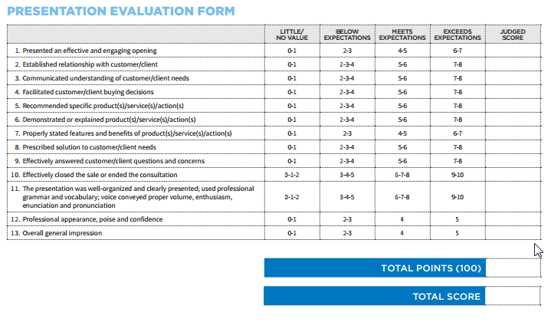

**YOUR ROLE**

* Sell your hotel and facilities to the meeting manager
  + Consider everything the group will need for the conference
* Arrange transportation from the airport and around the town
* Arrange 3 nights of entertainment that show-off your city’s unique culture